Computer Programming II: Lessons Learned and Reflection

Alejandro Ricciardi
Colorado State University Global
CSC320: Computer Programming II
Dr. Vanessa Cooper
August 4, 2024

Computer Programming II: Lessons Learned and Reflection
In the Computer Programming II course (CSC372) at Colorado State University Global, I developed a deeper understanding of Java and computer programming concepts. I had a great experience participating in the discussion forums. I particularly enjoyed exploring object-oriented design principles, especially the differences between abstract classes and interfaces covered in Module 4. Furthermore, working with JavaFX, introduced in Module 3, was both enjoyable and challenging. With the professor's approval, I implemented JavaFX Graphical User Interfaces (GUIs) in almost all my projects from Module 3 through Module 8. In this essay, I will explore the key lessons I have learned throughout this programming course. I will reflect on how these lessons applied to effective coding and to my future as a Computer Science professional.
Object-Oriented Programming
In Module 1 and 4, I learn the concept of class inheritance, abstract classes, and interfaces in the context of the Java programming language. I particularly enjoyed exploring object-oriented design concepts in Module 4, especially the nuanced differences between abstract classes and interfaces. Furthermore, in Module 1, I learned the concept of polymorphing in the context of Object-Oriented Programming (OOP). Polymorphing in Java is mostly where “subclasses of a class can define their own unique behaviors and yet share some of the same functionality of the parent class” (The Java™ Tutorials, n.d., p.1). I also learned about Unified Modeling Language (UML) and Class Responsibility Collaborator (CRC) to develop my coding projects.

Graphical User Interfaces (GUIs)
In Modules 2 and 3, I learn about Graphical User Interfaces (GUI) in Java. In Module 2, I explored the legacy Swing GUI components. I learn how to create windows, buttons, text fields, and other GUI elements. In Module 3, I was introduced to the more powerful JavaFX GUI Java library. It was particularly challenging but also very rewarding to implement the GUI. With the professor's approval, I implemented JavaFX GUIs in almost all my projects from Module 3 through Module 8.
Recursion
In Module 5, I learned about recursion, a powerful programming technique where a method calls itself. This was a challenging concept but also a very rewarding one when mastered. I learned to implement recursive methods but more importantly to identify when recursion is more appropriate than iteration. The example of using calculating factorials was very helpful to me in understanding this concept. Recursion is one of the key concepts in understanding algorithms used Computer Science, as it allows us to break up a large problem into smaller, more manageable subproblems.
Collections, Sorting, and Searching
In Modules 6 and 7, I learn about Java collections, sorting algorithms, and searching techniques. In module 6, I learned about various sorting and searching algorithms and their efficiency, using Big-O notation to analyze their performance. In module 7, I learned about the Collections framework, including ArrayList, HashMap, and TreeMap. I also learned about iterators and the differences between various collection types (like lists and sets), see Table 1. Learning about these concepts is essential to understand how to efficiently manipulate data.
Table 1
Lists vs Sets
List | Set
The List is an ordered sequence. | The Set is an unordered sequence
List allows duplicate elements | Set doesn’t allow duplicate elements.
Elements by their position can be accessed | Position access to elements is not allowed
Multiple null elements can be stored. | The null element can store only once
List implementations are ArrayList, LinkedList, Vector, Stack | Set implementations are HashSet, LinkedHashSet.
From: “List Interface in Java With Examples” by GeeksforGeeks (2020)
Stacks, Queues, and Exception Handling
In the final module, Module 8, I learned about stacks and queues, two fundamental data structures in Computer Science. I also learned how to implement and use these structures, understanding their LIFO (Last-In-First-Out) and FIFO (First-In-First-Out) behaviors respectively. Additionally, I learned about exception handling in Java as well as the Java Queue and Deque interfaces. Furthermore, in the last module, I understood better how the Java API works, and how classes and interfaces relate to each other in the Java Framework see Figure 1.
Figure 2
Java Class/Interface Framework — Class Hierarchy
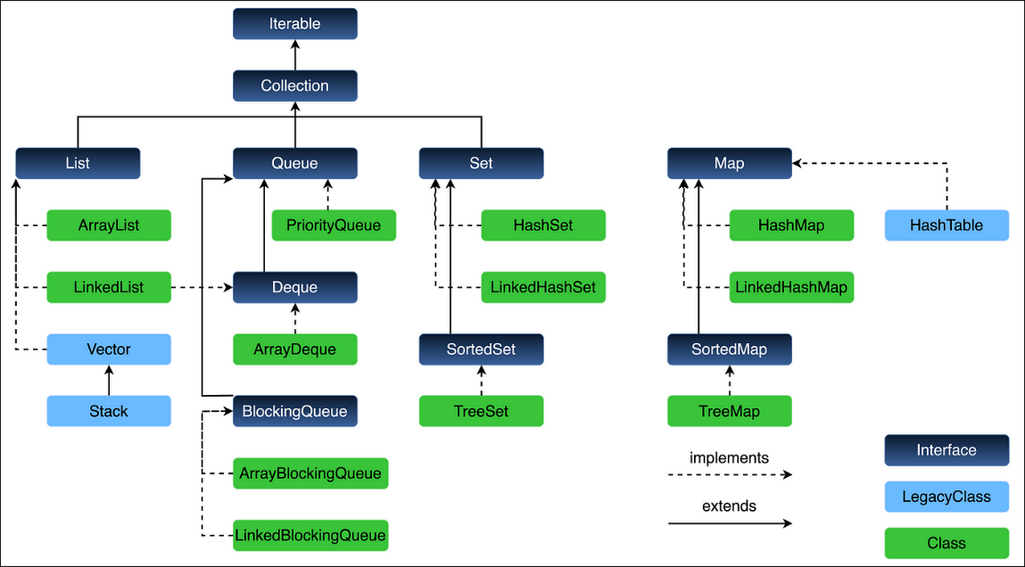
Note: The Map interface does not inherit from the Collection interface. From “Java Collections Framework — Class Hierarchy” by Gupta (2024).
Reflection
Concepts that I learned in this course, concepts such as class inheritance, abstract classes, interfaces, polymorphism, and object-oriented programming (OOP) will enable me to design robust and flexible software and AI applications in my professional career. Additionally, learning about GUI and applying it to my class projects has significantly enhanced my skills in understanding and creating interactive applications. Knowing how to use recursion has improved my understanding of algorithms. Furthermore, learning about collections, sorting, and searching has enhanced my understanding of how to use algorithms effectively. The ability to choose the right data structure for a specific task can significantly impact the performance and resource utilization of applications, which is a skill that is essential to manipulate large datasets in my future AI and machine learning projects. Moreover, learning about stacks, queues, and exception handling is also essential for understanding how to efficiently manipulate data.
Conclusion
The CSC372 Programming II course has significantly improved my Java programming skills and deepened my understanding of Computer Science concepts. Through Critical Thinking coding project that implemented object-oriented programming, GUI development, sort-search algorithms, and recursion, through discussions that improved my communication and critical thinking. Overall, this course has not only improved my coding skills, specifically in Java, but it has also enhanced my problem-solving abilities, preparing me well for a future career in Computer Science.
References
GeeksforGeeks. (2020, June 25). List interface in Java with examples. GeeksforGeeks. https://www.geeksforgeeks.org/list-interface-java-examples/
Gupta, V. (2024, January 2). Java collections framework — Class hierarchy. Medium. https://levelup.gitconnected.com/java-collections-framework-class-hierarchy-latest-2024-51f9154f1f57
The Java™ Tutorials (n.d.). Learning the Java language: Interfaces and inheritance. Oracle. Retrieved June 8, 2024, fromhttps://docs.oracle.com/javase/tutorial/java/IandI/polymorphism.html

